**Front-End UI/UX Mini Project**

**1. Title Page**

* **Project Title**: *"Recipe Book"*
* **Submitted By**:

1)*Neeraja M Yadav*

*2463040*

[*neeraja.m@btech.christuniversity.in*](mailto:neeraja.m@btech.christuniversity.in)

2)*Shalini T*

*2463052*

[*shalini.t@btech.christuniversity.in*](mailto:shalini.t@btech.christuniversity.in)

3)*Joshni Amshetha F*

*2463073*

[*joshni.amshetha@btech.christuniversity.in*](mailto:joshni.amshetha@btech.christuniversity.in)

* **Course**: *UI/UX Design Fundamentals*
* **Instructor Name**: Proff. Dhiraj
* **Institution**: *Christ University*
* **Date of Submission**: *26/09/2025*

**2. Abstract**

This project presents an Indian Recipe Book website designed to provide users with an engaging platform to explore authentic Indian culinary delights. Developed using HTML, CSS, and JavaScript with Bootstrap for responsive layout, the website showcases a curated collection of traditional Indian recipes with a focus on rich visuals, clear organization, and user-friendly interaction. Users can browse recipes categorized by meal type, difficulty, and dietary preference, and access detailed step-by-step cooking instructions along with ingredient lists. The design emphasizes elegance and readability through the use of modern typography, a harmonious color palette, and interactive elements such as search filtering and recipe detail views. The site is fully responsive, ensuring optimal experience across devices, and incorporates accessibility best practices. This project aims to blend cultural richness with contemporary web standards to facilitate home cooking of Indian dishes with ease and delight.

**3. Objectives**

* Provide a visually appealing and user-friendly platform to showcase authentic Indian recipes.
* Organize recipes by categories such as meal type, difficulty level, and dietary preferences for easy browsing.
* Enable users to quickly search and filter recipes by title or description keywords.
* Present each recipe with rich visuals, including images and styled badges indicating difficulty and dietary type.
* Provide detailed recipe views with step-by-step cooking instructions and ingredient lists.
* Ensure responsive design to support seamless access across different devices and screen sizes.
* Enhance user interaction via smooth transitions between recipe collection and detailed views.
* Use modern web standards (HTML5, CSS3, Bootstrap, and JavaScript) for maintainability and performance.
* Incorporate accessibility best practices such as semantic HTML and readable typography.
* Encourage easy home cooking by offering comprehensive, well-structured recipe information.

**4. Scope of the Project**

* To develop a dedicated website that catalogs a comprehensive selection of traditional Indian recipes.
* To provide detailed recipe information including ingredients, preparation steps, difficulty, dietary classification, and category.
* To enable easy browsing, filtering, and searching capabilities for diverse user needs and preferences.
* To deliver an engaging and elegant user interface ensuring an immersive culinary experience.
* To support multiple devices and screen sizes with a fully responsive design.
* To promote ease of use and accessibility catering to both novice and experienced cooks.
* To visually represent Indian culinary diversity with corresponding images and culturally relevant content.
* To allow future extension for adding more recipes, user accounts, ratings, or community features if needed.
* To maintain a modern, clean codebase built on HTML, CSS, Bootstrap, and JavaScript technologies.
* To serve as an educational and inspirational resource encouraging home cooking of Indian dishes.

**5. Tools & Technologies Used**

|  |  |
| --- | --- |
| Tool/Technology | Purpose |
| HTML5 | Website structure and semantic markup |
| CSS3 | Styling, layout and animations |
| VS Code | Code editor |
| Chrome DevTools | Testing and debugging |
| Pinterest images | Gallery content source |
| Google Fonts | Typography styling |
| Bootstrap 5 | Offer a responsive grid system, components, and utilities for layout and UI consistency. |
| jQuery | Simplify DOM manipulation, event handling, and AJAX operations to enhance interactivity. |
| JavaScript | Add interactivity such as recipe filtering, dynamic content rendering, and view transitions. |

**6. HTML Structure Overview**

* Semantic <html>, <head>, and <body> tags organize the page.
* Fixed-top <nav> for branding and navigation.
* Hero <section> with background image, heading, and button.
* Main container holds a search filter, recipe grid, and hidden detailed recipe view.
* Footer contains copyright and social icons.
* JavaScript manages dynamic recipe rendering and user interactions.
* Bootstrap grid ensures responsiveness and layout consistency.

**7. CSS Styling Strategy**

* Uses CSS custom properties for consistent color theming.
* Utilizes Google Fonts for elegant typography.
* Applies box shadows, border-radius, and transitions for modern UI.
* Ensures responsive design with media queries and Bootstrap grid.
* Defines utility classes and component-specific styles modularly.
* Prioritizes readability with padding/margins and color contrasts.
* Integrates hover and focus states for interactivity and accessibility.
* Combines global styles with scoped component styling for maintainability.

**8. Key Features**

|  |  |
| --- | --- |
| Feature | Description |
| Responsive Design | Uses Bootstrap grid and media queries to ensure the site adapts well across devices. |
| Recipe Collection | Displays recipes in card format with images, titles, categories, difficulty, and dietary badges. |
| Search Filter | Real-time filtering of recipes by title and description via a search input box. |
| Detailed Recipe View | Shows full recipe details including ingredients, preparation steps, and images in expandable view. |
| Interactive UI | Hover effects, clickable buttons, and smooth view transitions enhance user engagement. |
| Accessibility | Semantic HTML, ARIA roles, and keyboard navigable cards to improve usability for all users. |
| Visual Styling | Modern typography, custom colors, shadows, and border-radius create an elegant, consistent look. |
| Social Media Links | Footer contains icons linking to social platforms for extended engagement. |

**9. Challenges Faced & Solutions**

|  |  |
| --- | --- |
| Challenge | Solution |
| Ensuring Responsive Design | Used Bootstrap grid system and media queries for adaptable layouts across devices. |
| Managing Dynamic Content Rendering | Utilized JavaScript with jQuery for efficient DOM updates and event handling. |
| Providing Clear User Navigation | Implemented fixed-top navbar and smooth transitions between list and detail views. |
| Accessibility and Usability | Applied semantic HTML, ARIA roles, and keyboard focus management. |
| Optimizing Recipe Search Functionality | Added real-time search filtering on recipe titles and descriptions. |

**10. Outcome**

* Understanding of building mission-driven landing pages.
* Ability to organize content for persuasive storytelling and donation prompts.
* Skill in crafting visual emphasis on donation forms and call-to-action buttons.
* Improved usage of layout structures for informational and emotional storytelling.

**11. Future Enhancements**

* Add JavaScript for interactivity (form validation, dynamic content)
* Integrate animations or transitions
* Backend integration for form submission
* Theme toggler (light/dark mode)

**12. Sample Code:**

<!DOCTYPE html>

<html lang="en">

<head>

  <meta charset="UTF-8" />

  <meta name="viewport" content="width=device-width, initial-scale=1" />

  <title>Indian Recipe Book</title>

  <link href="https://cdn.jsdelivr.net/npm/bootstrap@5.3.0-alpha1/dist/css/bootstrap.min.css" rel="stylesheet" />

  <link href="https://fonts.googleapis.com/css2?family=Poppins:wght@400;500;600;700&family=Playfair+Display:wght@700&display=swap" rel="stylesheet" />

  <style>

    :root {

      --primary-color: #ff6b6b;

      --secondary-color: #4ecdc4;

      --dark-color: #292f36;

      --gray-light: #f9f9f9;

    }

    body {

      font-family: 'Poppins', sans-serif;

      background-color: var(--gray-light);

      color: var(--dark-color);

      padding-top: 80px;

      -webkit-font-smoothing: antialiased;

      -moz-osx-font-smoothing: grayscale;

    }

    h1, h2, h3, h4, h5 {

      font-family: 'Playfair Display', serif;

      font-weight: 700;

      color: var(--dark-color);

      position: relative;

      padding-bottom: 0.5rem;

      margin-bottom: 1.5rem;

    }

    h2::after {

      content: "";

      position: absolute;

      width: 60px;

      height: 4px;

      background: var(--primary-color);

      left: 0;

      bottom: 0;

      border-radius: 5px;

    }

    .navbar {

      background-color: white;

      box-shadow: 0 4px 25px rgba(0,0,0,0.08);

      padding: 16px 0;

      z-index: 10;

    }

    .navbar-brand {

      font-family: 'Playfair Display', serif;

      font-size: 2.5rem;

      font-weight: bold;

      color: var(--primary-color);

      letter-spacing: 2px;

      transition: color 0.3s ease;

    }

    .navbar-brand:hover,

    .navbar-brand:focus {

      color: var(--primary-color) !important;

      text-decoration: none;

    }

    .hero {

      background: linear-gradient(rgba(0,0,0,0.55), rgba(0,0,0,0.55)), url('https://i.pinimg.com/1200x/0f/64/8a/0f648a264b8179e13a7c6ff540da4e4f.jpg');

      background-size: cover;

      background-position: center;

      color: #ff6b6b;

      padding: 140px 0 100px;

      text-align: center;

      border-radius: 0 0 35px 35px;

      font-family: 'Playfair Display', serif;

      text-shadow: 0 0 10px #ff6b6b66;

    }

    .hero h1 {

      font-size: 4rem;

      font-weight: 900;

      margin-bottom: 1.2rem;

      letter-spacing: 4px;

      color: #ff6b6b;

      text-shadow: 0 0 10px #ff6b6b66;

    }

    .hero p {

      font-size: 1.4rem;

      max-width: 700px;

      margin: 0 auto 3rem;

      font-weight: 500;

      color: #ff6b6b;

      text-shadow: 0 0 10px #ff6b6b66;

    }

    .btn-primary {

      background-color: var(--primary-color);

      border: none;

      border-radius: 50px;

      padding: 14px 48px;

      font-size: 1.2rem;

      font-weight: 600;

      box-shadow: 0 6px 15px rgba(255,107,107,0.5);

      transition: all 0.3s ease;

      letter-spacing: 0.05em;

      text-transform: uppercase;

      cursor: pointer;

    }

    .btn-primary:hover {

      background-color: #ff5252;

      box-shadow: 0 8px 25px rgba(255,82,82,0.7);

      transform: translateY(-4px);

    }

    .filter-section {

      background: white;

      padding: 20px 40px 40px;

      border-radius: 30px;

      box-shadow: 0 8px 35px rgba(255,107,107,0.15);

      margin-bottom: 50px;

    }

    #searchInput {

      border-radius: 50px;

      border: 2px solid var(--primary-color);

      box-shadow: 0 5px 18px rgba(255,107,107,0.3);

      font-size: 1.1rem;

      padding: 15px 25px;

      font-weight: 500;

      transition: 0.3s ease;

      margin-bottom: 20px;

      width: 100%;

    }

    #searchInput:focus {

      outline: none;

      border-color: #ff4c4c;

      box-shadow: 0 8px 28px rgba(255,76,76,0.6);

    }

    .recipe-card {

      background: white;

      border-radius: 25px;

      box-shadow: 0 12px 30px rgba(255, 107, 107, 0.20), 0 4px 20px rgba(0, 0, 0, 0.07);

      cursor: pointer;

      display: flex;

      flex-direction: column;

      height: 100%;

      transition: all 0.3s ease;

      padding: 0;

    }

    .recipe-card:hover {

      transform: translateY(-12px);

      box-shadow: 0 20px 52px rgba(255, 82, 82, 0.35), 0 5px 25px rgba(0, 0, 0, 0.12);

    }

    .recipe-img {

      height: 220px;

      border-radius: 25px 25px 0 0;

      background-size: cover;

      background-position: center center;

      filter: drop-shadow(0 0 0.2rem rgba(255, 107, 107, 0.4));

    }

    .recipe-content {

      flex-grow: 1;

      display: flex;

      flex-direction: column;

      justify-content: space-between;

      padding: 28px 30px 30px;

    }

    .recipe-title {

      font-family: 'Playfair Display', serif;

      font-weight: 700;

      font-size: 1.9rem;

      color: var(--primary-color);

      margin-bottom: 12px;

      letter-spacing: 0.03em;

      min-height: 2.5em;

    }

    .recipe-meta {

      display: flex;

      gap: 18px;

      font-size: 1rem;

      font-weight: 600;

      color: #555;

      flex-wrap: wrap;

      margin-bottom: 24px;

    }

    .badge {

      padding: 6px 18px;

      border-radius: 30px;

      font-size: 0.95rem;

      text-transform: capitalize;

      font-weight: 600;

      background: linear-gradient(90deg, #ff6b6b 0%, #ffe66d 100%);

      color: #fff;

      box-shadow: 0 0 18px #ffa1a1b0;

      transition: 0.3s ease;

    }

    .badge-easy {

      background: linear-gradient(90deg, #4ecdc4 0%, #2a9d8f 100%);

      box-shadow: 0 0 16px #4ecdc4aa;

      color: white;

    }

    .badge-medium {

      background: linear-gradient(90deg, #ffe66d 0%, #f4a261 100%);

      box-shadow: 0 0 16px #fff3a1aa;

      color: #444;

    }

    .badge-hard {

      background: linear-gradient(90deg, #ff6b6b 0%, #ea2027 100%);

      box-shadow: 0 0 16px #ff6b6bcc;

      color: white;

    }

    .recipe-description {

      font-size: 1.1rem;

      color: #444;

      margin-bottom: 24px;

      font-weight: 400;

      letter-spacing: 0.01em;

      flex-grow: 1;

      min-height: 3.4em;

    }

    .view-recipe-btn {

      padding: 10px 28px;

      font-weight: 700;

      font-size: 1rem;

      border-radius: 60px;

      color: var(--primary-color);

      border: 3px solid var(--primary-color);

      background-color: transparent;

      transition: all 0.3s ease;

      letter-spacing: 0.07em;

      text-transform: uppercase;

      align-self: flex-start;

      cursor: pointer;

    }

    .view-recipe-btn:hover {

      background-color: var(--primary-color);

      color: white;

      box-shadow: 0 6px 18px rgba(255, 107, 107, 0.55);

      transform: translateY(-3px);

      border-color: var(--primary-color);

    }

    #recipeDetail {

      background: white;

      border-radius: 30px;

      padding: 40px 35px;

      box-shadow: 0 12px 35px rgba(255, 107, 107, 0.15);

      margin-bottom: 60px;

    }

    .recipe-detail-img {

      height: 450px;

      border-radius: 30px;

      background-size: cover;

      background-position: center;

      box-shadow: 0 8px 24px rgba(255, 107, 107, 0.3);

      margin-bottom: 25px;

    }

    #detailTitle {

      font-family: 'Playfair Display', serif;

      font-weight: 900;

      font-size: 3rem;

      color: var(--primary-color);

      margin-bottom: 10px;

    }

    .recipe-meta {

      font-size: 1.1rem;

      margin-bottom: 20px;

      gap: 12px;

    }

    .ingredients-list,

    .steps-list {

      padding-left: 24px;

      font-weight: 500;

      font-size: 1.1rem;

      line-height: 1.7;

      color: #555;

      margin-bottom: 30px;

    }

    .ingredients-list li,

    .steps-list li {

      margin-bottom: 14px;

    }

    .back-btn {

      margin-bottom: 40px;

      border-radius: 50px;

      padding: 12px 38px;

      font-weight: 600;

      font-size: 1.1rem;

      color: var(--primary-color);

      border: 3px solid var(--primary-color);

      background-color: transparent;

      transition: all 0.3s ease;

      letter-spacing: 0.07em;

      display: inline-flex;

      align-items: center;

      gap: 10px;

      text-decoration: none;

      cursor:pointer;

    }

    .back-btn:hover {

      background-color: var(--primary-color);

      color: white;

      box-shadow: 0 6px 18px rgba(255, 107, 107, 0.55);

      transform: translateY(-3px);

      border-color: var(--primary-color);

      text-decoration: none;

    }

    footer {

      background-color: var(--dark-color);

      color: white;

      padding: 50px 0 25px;

      margin-top: 50px;

      font-size: 0.95rem;

    }

    footer p {

      margin: 0;

    }

    .social-icons a {

      color: white;

      font-size: 1.7rem;

      margin-right: 25px;

      transition: color 0.3s ease;

      text-decoration: none;

    }

    .social-icons a:hover {

      color: var(--primary-color);

    }

    @media (max-width: 992px) {

      .hero h1 {

        font-size: 2.8rem;

      }

      #detailTitle {

        font-size: 2.2rem;

      }

      .recipe-detail-img {

        height: 300px;

      }

    }

    @media (max-width: 768px) {

      .col-md-4 {

        flex: 0 0 100%;

        max-width: 100% !important;

      }

    }

    @media (max-width: 576px) {

      .hero {

        padding: 80px 20px 60px;

      }

      #searchInput {

        margin-bottom: 30px;

      }

      .recipe-title {

        font-size: 1.5rem;

      }

      .recipe-meta {

        font-size: 0.9rem;

        gap: 8px;

      }

      .recipe-description {

        font-size: 1rem;

      }

    }

  </style>

</head>

<body>

<nav class="navbar navbar-expand-lg fixed-top">

  <div class="container">

    <a class="navbar-brand" href="#">Indian Recipe Book</a>

    <button class="navbar-toggler" type="button" data-bs-toggle="collapse" data-bs-target="#navbarNav" >

      <span class="navbar-toggler-icon"></span>

    </button>

    <div class="collapse navbar-collapse" id="navbarNav"></div>

  </div>

</nav>

<section class="hero">

  <div class="container">

    <h1>Discover Indian Culinary Delights</h1>

    <p>Explore authentic Indian dishes with easy-to-follow recipes and stunning visuals.</p>

    <a href="#recipes" class="btn btn-primary">Explore Recipes</a>

  </div>

</section>

<div class="container my-5">

  <section class="filter-section" id="filters">

    <input type="text" class="form-control" id="searchInput" placeholder="Search recipes..." />

  </section>

  <section id="recipes" class="mb-5">

    <h2>Recipe Collection</h2>

    <div class="row g-4" id="recipesList"></div>

  </section>

  <section id="recipeDetail" style="display:none;">

    <a href="#" id="backBtn" class="back-btn"><i class="fa fa-arrow-left"></i> Back to Recipes</a>

    <div class="recipe-detail">

      <div class="row">

        <div class="col-md-6">

          <div class="recipe-detail-img" id="detailImage"></div>

        </div>

        <div class="col-md-6">

          <h2 id="detailTitle"></h2>

          <div class="recipe-meta" id="detailMeta"></div>

          <p id="detailDescription"></p>

          <h4>Ingredients</h4>

          <ul class="ingredients-list" id="detailIngredients"></ul>

        </div>

        <div class="col-12 mt-4">

          <h4>Preparation Steps</h4>

          <ol class="steps-list" id="detailSteps"></ol>

        </div>

      </div>

    </div>

  </section>

</div>

<footer>

  <div class="container d-flex flex-column flex-md-row justify-content-between align-items-center">

    <p>© 2025 Indian Recipe Book. All rights reserved.</p>

    <div class="social-icons">

      <a href="#" aria-label="Facebook" title="Facebook"><i class="fab fa-facebook"></i></a>

      <a href="#" aria-label="Instagram" title="Instagram"><i class="fab fa-instagram"></i></a>

      <a href="#" aria-label="Pinterest" title="Pinterest"><i class="fab fa-pinterest"></i></a>

      <a href="#" aria-label="YouTube" title="YouTube"><i class="fab fa-youtube"></i></a>

    </div>

  </div>

</footer>

<script src="https://code.jquery.com/jquery-3.7.1.min.js"></script>

<script src="https://cdn.jsdelivr.net/npm/bootstrap@5.3.0-alpha1/dist/js/bootstrap.bundle.min.js"></script>

<script>

  const recipes = [

    {

      id: 1,

      title: "Hyderabadi Biryani",

      description: "Fragrant basmati rice layered with marinated meat and cooked to perfection with spices.",

      category: "Main",

      difficulty: "Hard",

      dietary: "Non-Vegetarian",

      image: "https://i.pinimg.com/736x/a9/1c/81/a91c81e23516e85e10205a2f3e58bfa8.jpg",

      ingredients: [

        "2 cups basmati rice", "500 g chicken", "Yogurt", "Fried onions", "Mint and coriander leaves",

        "Biryani masala", "Ginger garlic paste", "Saffron soaked in milk", "Oil", "Salt"

      ],

      steps: [

        "Marinate chicken with yogurt and spices.",

        "Parboil basmati rice with whole spices.",

        "Layer rice and marinated chicken in a pot.",

        "Cook on low heat till meat is tender and flavors meld.",

        "Serve hot garnished with fried onions."

      ]

    },

    {

      id: 2,

      title: "Masala Dosa",

      description: "Crispy rice crepes filled with spicy mashed potatoes.",

      category: "Breakfast",

      difficulty: "Medium",

      dietary: "Vegetarian",

      image: "https://i.pinimg.com/736x/48/c7/62/48c7623f80f000107f3a6e305abea7f7.jpg",

      ingredients: [

        "Dosa batter", "2 boiled potatoes", "1 onion", "1 tsp mustard seeds",

        "Curry leaves", "Turmeric", "Chopped green chilies", "Salt"

      ],

      steps: [

        "Prepare potato filling with spices.",

        "Spread dosa batter on hot pan.",

        "Add potato filling, fold dosa, cook till crisp.",

        "Serve with chutney and sambar."

      ]

    },

    {

      id: 3,

      title: "Chettinad Chicken",

      description: "Spicy and flavorful South Indian chicken curry with aromatic spices and coconut.",

      category: "Main",

      difficulty: "Hard",

      dietary: "Non-Vegetarian",

      image: "https://i.pinimg.com/736x/93/48/22/9348229164d4d1896e85f525613a61da.jpg",

      ingredients: [

        "500g chicken", "Onions", "Tomatoes", "Coconut grated", "Chettinad masala",

        "Red chili powder", "Turmeric", "Curry leaves", "Ginger garlic paste", "Oil", "Salt"

      ],

      steps: [

        "Sauté onions, ginger garlic paste and spices.",

        "Add chicken and cook till tender.",

        "Add coconut and simmer till gravy thickens.",

        "Serve hot with rice."

      ]

    },

    {

      id: 4,

      title: "Chole Bhature",

      description: "Spicy chickpea curry served with fried bread.",

      category: "Main",

      difficulty: "Hard",

      dietary: "Vegetarian",

      image: "https://i.pinimg.com/736x/f5/9c/9a/f59c9a7f63c2cd4bd587f3de73f184a4.jpg",

      ingredients: [

        "2 cups chickpeas", "Onions", "Tomatoes", "Ginger garlic paste",

        "Chole masala", "Flour for bhature", "Oil", "Spices"

      ],

      steps: [

        "Soak and boil chickpeas.",

        "Prepare spicy onion-tomato gravy.",

        "Add chickpeas and simmer.",

        "Make dough and deep fry bhature.",

        "Serve together hot."

      ]

    },

    {

      id: 5,

      title: "Rasam",

      description: "Tangy and spicy South Indian soup made with tamarind and spices.",

      category: "Soup",

      difficulty: "Easy",

      dietary: "Vegan",

      image: "https://i.pinimg.com/1200x/fb/7e/83/fb7e83b33a9aef549dd1cd67815a2d93.jpg",

      ingredients: [

        "Tamarind", "Tomatoes", "Black pepper", "Cumin", "Mustard seeds",

        "Garlic", "Curry leaves", "Salt"

      ],

      steps: [

        "Boil tamarind extract with tomatoes and spices.",

        "Temper mustard seeds, cumin, and curry leaves.",

        "Add tempering to rasam and serve hot."

      ]

    },

    {

      id: 6,

      title: "Gulab Jamun",

      description: "Soft deep-fried milk dumplings soaked in rose sugar syrup.",

      category: "Sweet",

      difficulty: "Medium",

      dietary: "Vegetarian",

      image: "https://i.pinimg.com/736x/89/c2/72/89c272ed94146f5c360adbebbea6ed4a.jpg",

      ingredients: [

        "Khoya", "Flour", "Milk", "Sugar", "Rose water", "Cardamom powder", "Oil for frying"

      ],

      steps: [

        "Make dough with khoya and flour.",

        "Shape into balls and deep fry.",

        "Soak in warm sugar-rose syrup.",

        "Serve warm or chilled."

      ]

    }

  ];

  function renderRecipes() {

    const container = $('#recipesList');

    container.empty();

    recipes.forEach(recipe => {

      const difficultyClass = recipe.difficulty.toLowerCase() === 'easy' ? 'badge-easy' : recipe.difficulty.toLowerCase() === 'medium' ? 'badge-medium' : 'badge-hard';

      const card = `

        <div class="col-md-4">

          <div class="recipe-card" tabindex="0" role="button" aria-pressed="false" aria-label="${recipe.title}">

            <div class="recipe-img" style="background-image: url('${recipe.image}');"></div>

            <div class="recipe-content">

              <h3 class="recipe-title">${recipe.title}</h3>

              <div class="recipe-meta">

                <span>${recipe.category}</span>

                <span class="badge ${difficultyClass}">${recipe.difficulty}</span>

                <span>${recipe.dietary}</span>

              </div>

              <p class="recipe-description">${recipe.description}</p>

              <button class="view-recipe-btn btn btn-primary mt-auto" data-id="${recipe.id}">View Recipe</button>

            </div>

          </div>

        </div>

      `;

      container.append(card);

    });

    $('.view-recipe-btn').on('click', function() {

      const id = $(this).data('id');

      showRecipeDetails(id);

    });

  }

  function showRecipeDetails(id) {

    const recipe = recipes.find(r => r.id == id);

    if (!recipe) return;

    $('#recipes').hide();

    $('#recipeDetail').show();

    $('#detailImage').css('background-image', `url(${recipe.image})`);

    $('#detailTitle').text(recipe.title);

    $('#detailMeta').html(`

      <span class="me-3"><strong>Category: </strong>${recipe.category}</span>

      <span class="me-3 badge ${recipe.difficulty.toLowerCase() === 'easy' ? 'badge-easy' : recipe.difficulty.toLowerCase() === 'medium' ? 'badge-medium' : 'badge-hard'}">${recipe.difficulty}</span>

      <span><strong>Dietary: </strong>${recipe.dietary}</span>

    `);

    $('#detailDescription').text(recipe.description);

    const ingredientsList = $('#detailIngredients').empty();

    recipe.ingredients.forEach(i => ingredientsList.append(`<li>${i}</li>`));

    const stepsList = $('#detailSteps').empty();

    recipe.steps.forEach(s => stepsList.append(`<li>${s}</li>`));

  }

  $('#backBtn').on('click', function(e) {

    e.preventDefault();

    $('#recipeDetail').hide();

    $('#recipes').show();

  });

  $('#searchInput').on('input', function() {

    const val = $(this).val().toLowerCase();

    const filtered = recipes.filter(r =>

      r.title.toLowerCase().includes(val) || r.description.toLowerCase().includes(val)

    );

    renderRecipes(filtered);

  });

  $(document).ready(function() {

    renderRecipes();

  });

</script>

</body>

</html>

**10. Screenshots of the output:**

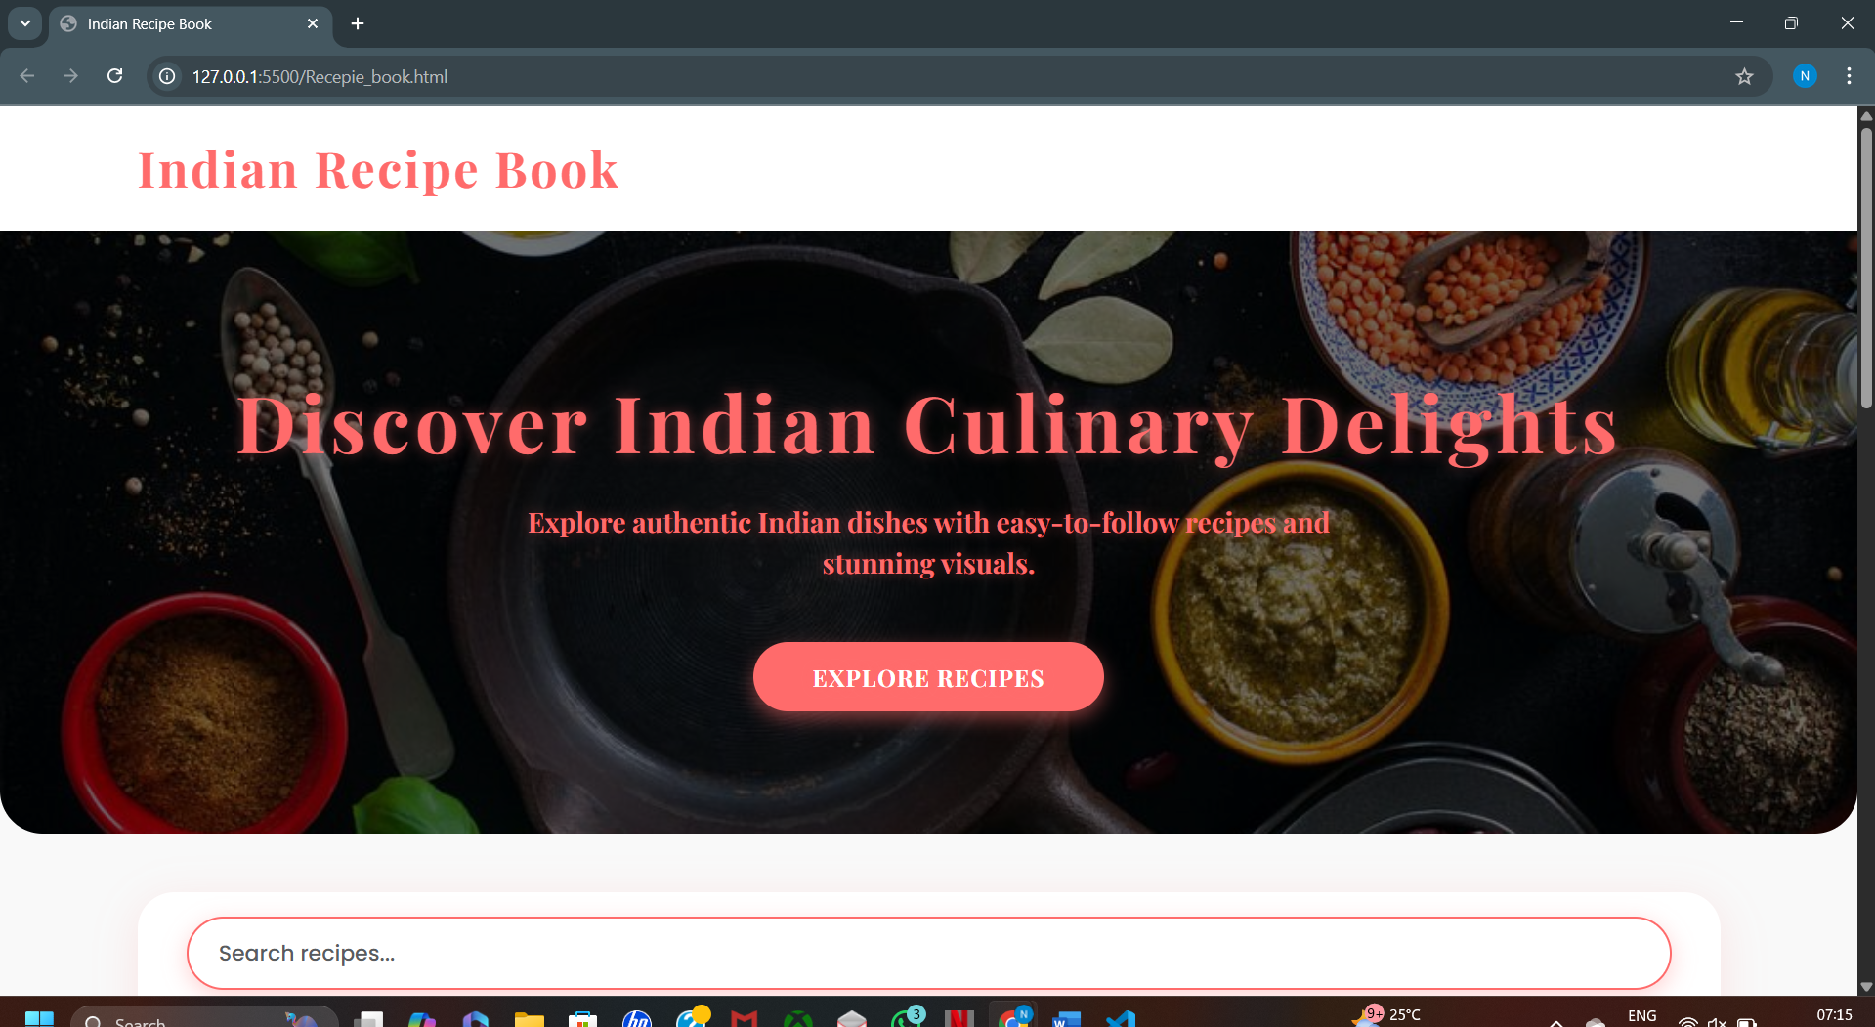

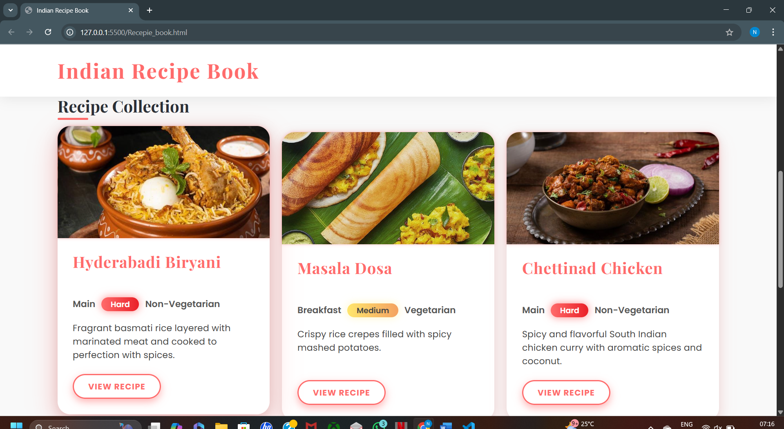

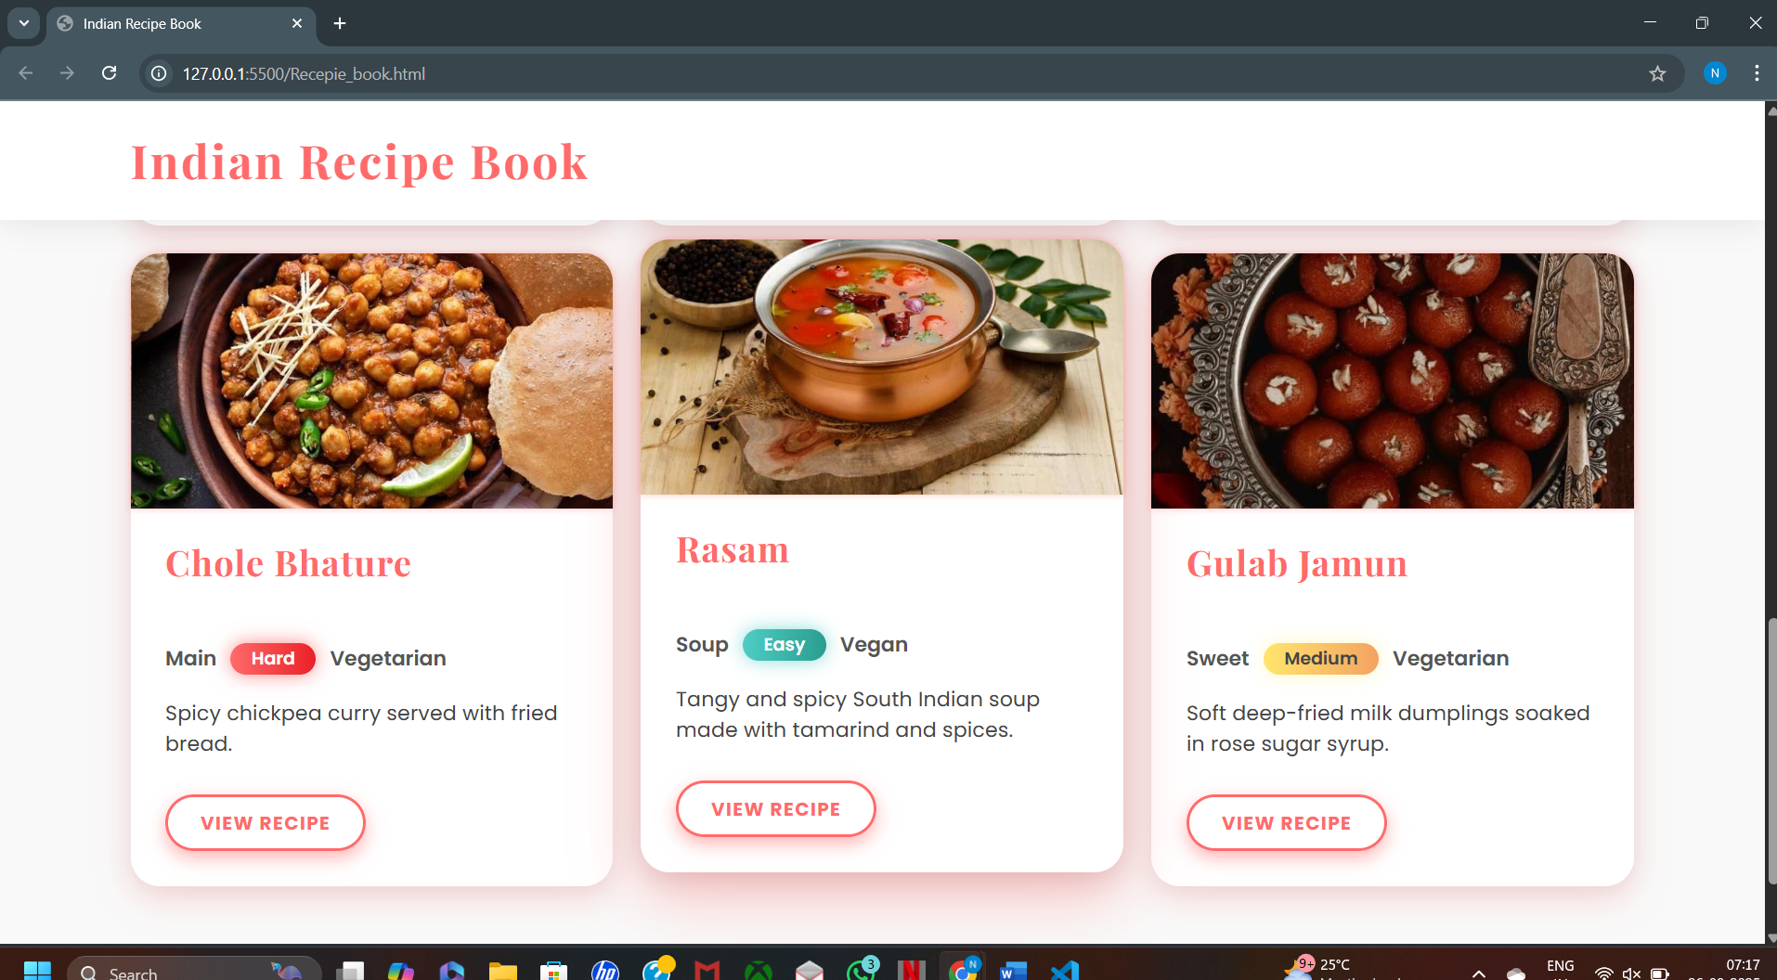

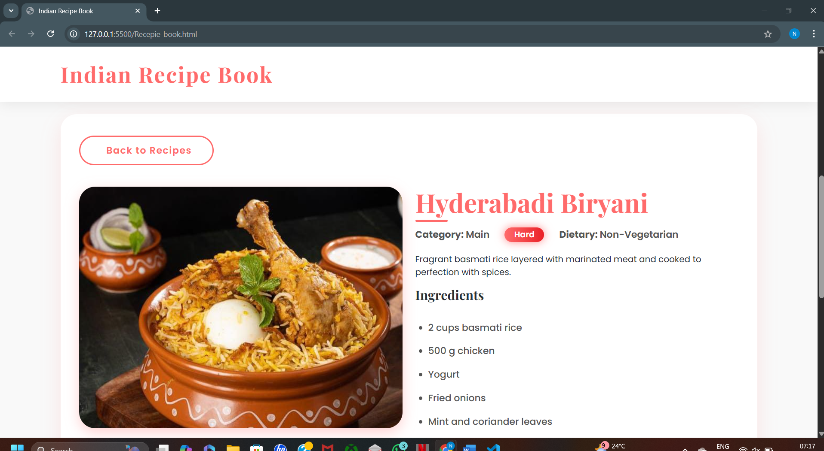

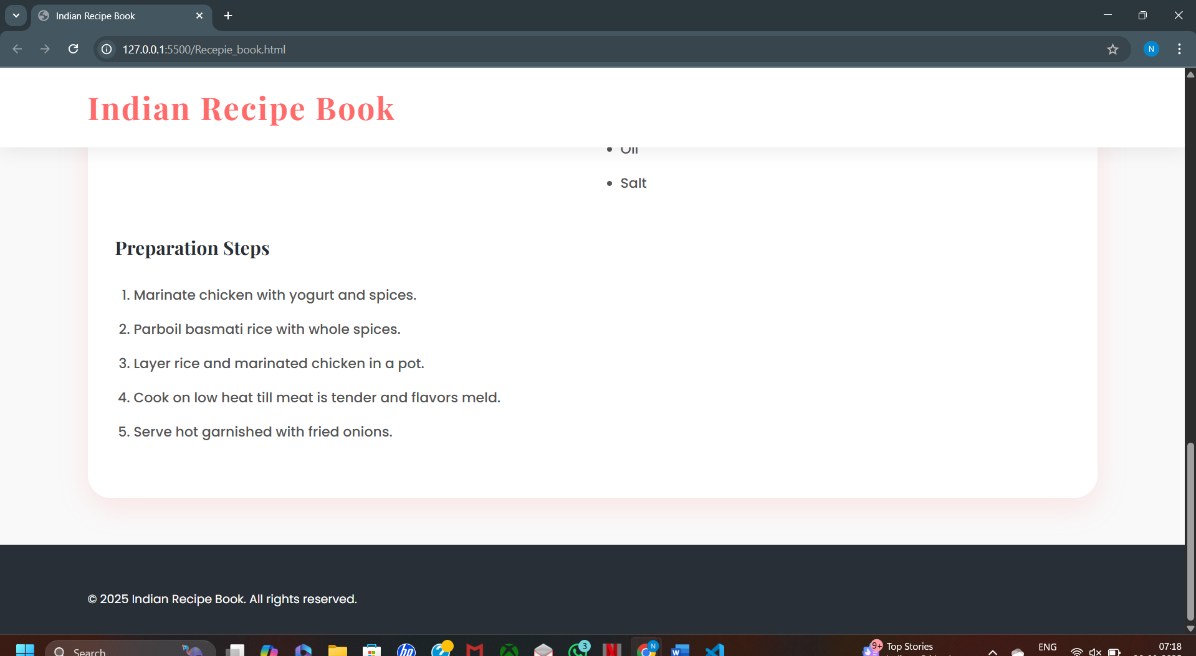

**11. Conclusion**

The Indian Recipe Book project successfully delivers a responsive and interactive web-based platform for showcasing traditional Indian recipes. By integrating modern web technologies like HTML5, CSS3, Bootstrap, and JavaScript, the site provides a visually appealing and user-friendly interface for recipe exploration, searching, and detailed viewing. It combines aesthetic design with functional interactivity, supporting diverse user needs and enhancing accessibility. This project demonstrates practical skills in front-end development while promoting Indian culinary culture in a digital format. Future enhancements can further enrich user engagement and content management, making the platform scalable and dynamic for broader audiences.

**12. References**

* L&T LMS : <https://learn.lntedutech.com/Landing/MyCourse>
* Google Fonts: Playfair and raleway
* Pinterest- Image source
* W3schools- reference